Deposited 10 ether

Added 1 additional ether

Added 1 either as 1000000000000000000 wei

Added 10 ether as 10000000000000000000 wei

Deposited 5 ether

Withdraw 5 ether to accountOne

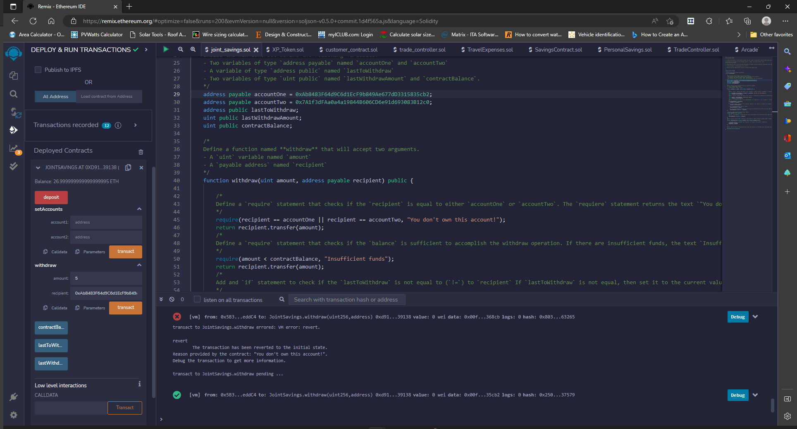

Withdrawal 10 ether to accountTwo

After depositing 5 ether, withdrew 5 ether to accountOne – Terminal indicates deposit and withdraw

